Preserving Fanfiction: What the fans want?

Shandra Morehouse

University of Maryland - College Park

Abstract

Fanfiction is a popular form of media in online fan communities -- it brings fans together through writing. Fans write and post fanfiction on platforms like Archive of Our Own (ao3) and social media (like Twitter and tumblr).Through these stories, fans can change canon to make it fit their needs and it can also cultivate friendships. For archivists and other information professionals, preserving fanfiction seems like an obvious choice: fanfiction is rich in fandom history and can be a valuable insight into a fandom community. Preservation is also great for fanfiction readers who love a story and go back to read it again, only to discover that it has been deleted for whatever reason. However, the preservation of fanfiction is not necessarily what fans, and fanfiction writers in particular, may want for their works. This paper explores this topic by looking at the Society of American Archivists’ Core Values: Preservation, Access and Use, and Diversity.

*Keywords: fanfiction, preservation, ethical considerations, fan studies*

**Introduction**

Fanfiction (or fanfic, or fic) is a type of fanwork that is created by fans of a specific form of media like *Harry Potter*, *Game of Thrones*, or *Marvel* movies. These writings are published online (for free) for other fans to read and enjoy. Fanfiction has a very long history - *Sherlock Holmes* fanfiction was being written in the 1890s, *Star Trek* fans wrote Kirk/Spock fanfiction in fan zines, and early adopters of the internet wrote *Buffy* and *X-Files* fanfiction (Jamison, 2013). The internet has made fanfiction even more accessible and prevalent in fan communities. In addition, the affordances of the internet have changed the way fanfiction (the form or genre) is created and shared.

For fans, the idea of preserving fanfiction can be as simple as wanting to come back to read a fic that you really enjoyed, or it could be more general and noble as a means to preserve fandom history. Fanfiction has a habit of disappearing due to a variety of reasons: authors take down their work, fan sites where fic is published disappear, and most recently, fic is being posted on (and sometimes solely on) social media sites, which means it is easily lost in the internet abyss. Because social media is becoming a common platform for fanfiction communities, finding a way to preserve fanfiction has become a lot more challenging.

As archivists and information professionals, we value the preservation of artifacts, digital or otherwise, that are an important part of a culture. According to the Society of American Archivists’ (SAA) Core Values Statement (2011), “archivists select, preserve, and make available primary sources that document the activities of institutions, communities, and individuals. These archival sources can be used for many purposes, including providing legal and administrative evidence, protecting the rights of individuals and organizations, and forming part of the cultural heritage of society.” Preserving fan creations falls into this cultural heritage category. One example of fanfiction in archival collections is *FellowsHub: A Tolkien Fanzine Project* from the Raynor Library Archives at Marquette University. This digital library contains digitized copies of *Lord of the Rings* fanfiction found in fanzines from the 1950s and 1960s.[1] The collection contains digitized images of the fanzines themselves and can be searched by the creator/author, the story/article, or by the whole fanzine.

In addition to collecting fanzines from the days before the internet, there has been a lot of discussion (and some work) on preserving fanfiction that is posted online. While the work being done to preserve fanfiction is important, there are still some concerns from the fan communities, and those that study fandoms, about what is required to preserve fanfiction, the privacy risks associated with preserving and accessing fanfiction, the expectations fans have about the longevity of their work, and the narrative being written by the preservation of these works.

To further explore this issue, this paper examines the preservation of fanfiction in the context of the Society of American Archivists’ Core Values, *Preservation*, *Diversity*, and *Access and Use*. SAA’s Core Values statement is created to guide both professional archivists and those that work closely with archivists to define the values as a profession (SAA, 2011). These guidelines include several Core Values including Access and Use, Accountability, Advocacy, Diversity, History and Memory, Preservation, Professionalism, Responsible Custody, Selection, Service, and Social Responsibility. This paper focuses on three of these core values in the context of preservation of online fanfiction.

These core values of archivists can cause tensions with the expectations of fans and fanfiction authors. While archivists value the preservation of cultural material and would like to provide the highest amount of access possible for future users, many fanfiction authors use the fan community as a way to escape everyday life, and there is often an unspoken expectation, especially for queer fans, that fan content will be kept within the community (Dym and Fiesler, 2018). Therefore, this paper will use the following research questions to guide this exploration of tensions between archivist’s values and fan expectations.

1. What tensions arise between the preservation of fanfiction and the privacy and expectations of fanfiction authors?
2. What tensions arise between the continued use and access of fanfiction and the privacy and expectations of fanfiction authors?
3. How can archivists and other information professionals leverage their value in diversity to provide a diverse and accurate portrayal of fan communities?

**What is Fanfiction and Why is it Important?**

Before delving into the issues associated with the preservation of fanfiction, this section will give a brief overview of the relevant aspects of the online fanfiction community. Fanfiction is not new. There are several examples throughout literary history of fanfiction being written. One notable example is the original *Sherlock Holmes* fandom. Jamison (2013) writes about the *Sherlock Holmes* fandom, and specifically discusses how fans, upset with the death of their favorite character, wrote fanfiction, and even sent it to the author, Arthur Conan Doyle. Similarly, the *Star Trek* fandom is also often talked about when it comes to the history of fanfiction. *Star Trek* is the birth of modern fandom, creating norms for fanfiction and shipping, and more specifically, the shipping of two male characters (Jamison, 2013). The term *shipping* refers to the practice of fans wanting two characters to be in a relationship together. In the case of *Star Trek*, this was often Kirk and Spock. These fan written stories were distributed on paper at conventions and in fan zines (Jamison 2013).

Although the medium has changed, and paper has been exchanged for digital stories, fans still commonly ship same sex characters, even if, or especially if, it is not canon (canon refers to events that happened in the original media, as opposed to fanon which is a common understanding or idea about the media that is widely agreed upon in the fandom). Fans have been using the internet to share fanfiction with fellow fans for nearly as long as the internet itself. Versaphile (2011) gives a detailed overview of fanfiction on the web starting with Geocities and Usenet through LiveJournal and fanfiction.net and finally to Archive of Our Own (ao3) and tumblr. Earlier sites like LiveJournal and other private sites were fandom specific, meaning there were dedicated fan sites for specific fandoms like *X-Files* or *Buffy the Vampire Slayer* (Jamison, 2013). Each fanfiction author had their own LiveJournal account where they posted their fic and then the fandom community would link to the story. Later, with fanfiction.net and Archive of Our Own, fans from all sorts of fandoms could write and post their works in a multi fandom archive (Versaphile, 2011).

More recently, fanfiction is not restricted to traditional prose works on a multi-fandom archive. Social media has allowed for fans to use innovative ways to tell stories. This can be as simple as a fanfiction being posted in a series of tweets on Twitter (a threadfic) or a social media au[2]. In social media aus, fans take inspiration from their own experiences on social media and use apps that create fake social media accounts and tell stories through social media screenshots. While social media is a great way for fanfiction writers to reach their audience, it is a difficult medium to preserve (Thomson and Kilbride, 2015).

When talking about the creation and ideas around the creation of ao3, Lothian (2013) talks about the goals of ao3: “[the archive] mobilizes subcultural memory in the service of transformation of online fannish temporality that would give fandom’s archive cultures a traceable history to claim with pride and a future to look forward to” (p. 547). While this is definitely a great reason to preserve fanfiction, the original goal when undertaking this project was a lot more personal: I’m an avid fanfiction reader, and it breaks my heart when I read a great fic and then lose track of it. So I set about looking into the preservation of fanficiton, but, as indicated by this paper, it’s easier said than done; there are many ethical and political concerns that need to be addressed when working to preserve fanfiction and other fanworks.

**Preservation**

*SAA’s Core Value of Preservation*

SAA’s Core Value of Preservation focuses on the responsibility of archivists preserving primary sources for future generations, whether this be the artifact itself, or the content of the artifact (SAA, 2011). This idea of preserving fanfiction for future generations is a great motivating factor for this research. Finding a great, well written fanfiction that treats your favorite characters how they deserve to be treated (not always the case for mainstream media) is just like finding a favorite book. You want to put it on your bookshelf so that you can come back to read it over and over again, or take it off the shelf and just read your favorite parts when you don’t have time for the whole book. Or give it to a friend so they can share the experience of reading your favorite story.

For fanfiction, this is a little different. Fanfiction readers will still share their favorite stories with other fans via links, but the main difference is in how these stories are accessed and saved (or not). Some readers will download all of the stories they read. Others just come back to them via a saved or bookmarked link (ao3 has a way to bookmark links for stories you like). This latter option is a little risky because there are many things that can make a story unavailable later on. If a fic is posted on a smaller fandom website, the story, the author, and the reader are all at the mercy of the person(s) running the site and if the site shuts down, then all the work on the website will be lost. Or, even if a work is posted on a stable website like ao3, the reader is at the mercy of the author -- fanfiction authors are able to take down their work whenever they want. Therefore, the format of the preserved fic must be addressed. Is the original format of the fan work important? Or is it the content of the work itself? There is something to be said for an authentic experience with reading in the original format (where you can often see other reader’s feedback like comments and kudos, which adds to the feeling of community in fanfiction. However, there are already many readers who do not engage with the community when reading fanfic and often download the works, so as a community, fanfiction readers seem to value the content over an authentic fan community experience.

*Archive of our Own: A Fan-run Preservation Project*

Archive of our Own is a multifandom archive for fanfiction and other fanworks. The archive is run by a non-profit organization called the Organization for Transformative Works (OTW). The OTW’s mission is to advocate and preserve fanworks. In addition to providing a platform for fans to post their work on, OTW works to preserve single fandom fic archives by importing them into ao3 (Home, 2019). The Archive is run completely by fan volunteers, including volunteers who ‘wrangle’ tags to make fics more searchable and volunteer lawyers who advocate for the legality of fanfiction and argue that fanfiction does not infringe on copyright (Lothian, 2013).

The idea for ao3 was formed in response to the commercialization of fanfiction archives like fanfiction.net and FanLib, which fans felt was exploiting the marketability of fanfiction writers (Lothian, 2013). The idea for a fan run archive came in 2007 on LiveJournal from user Astolat: “We need a central archive of our own…[that] would clearly state our case for the legality of our hobby up front” (Coppa, 2013, p. 305). Necessary features for an archive of this sort would be an archive “run BY fanfic readers FOR fanfic readers, with no ads and solely donation-supported, with a simple and highly searchable interface and browsable quick-search pages, allowing ANYTHING [content wise]...and allowing the poster to control her stories (ie, upload, delete, edit, tagging)” (Coppa, 2013, p. 305). All of these features are the backbone of today’s ao3 web experience.

Most relevant to this paper is the last point about allowing the poster to control their own stories. At the time where fans were organizing and evaluating important features that would be desirable in a fanfic platform, it is telling that fans listed the control of their work as something important. The implication being that the work should always belong to the author, to do with the story as they please. If this is the case, then it stands to reason that authors would want to be notified if their work was going to be preserved or added to a separate archive.

*Fanfiction on Social Media and the Preservation Thereof*

As social media became an integral part of our daily lives, so too did social media become an integral part of fandom. The affordances of social media has evolved the way fans interact with content creators. In general, content creators like writers, producers, and actors are a lot more accessible to fans on social media. Hagen (2015) focuses on the music fandom, specifically the fans of bands like Good Charlotte and Panic! at the Disco. This fandom has an important distinguishing factor from many other mainstream fandoms: the fans write fanfiction about real people. Writing fanfiction about real people is not popular in all fan groups (for the obvious reasons, like invasion of privacy, and just generally not being thought of as acceptable or appropriate), but tends to be popular in music fandoms (bandom): One Direction, kpop (Korean pop music) groups, and the aforementioned Good Charlotte and Panic! at the Disco. Hagen’s (2015) article focuses on how the band member’s own social media accounts and blogs played a large role in the fanfiction that was being written about them. Any content the band posted was fair game for fanfiction writers to do with as they please. And this affected the band too. In response to their fans shipping them, the bands engaged in what Hagen (2015) calls “stage gay” -- playing up the fan’s ships with on stage actions (the implications of which are out of scope for this paper, unfortunately).

While definitely not a new phenomenon, building and cultivating friendships has never been easier thanks to social media (Šesek & Pušnik, 2014). Most fans ‘meet’ in fan spaces, usually about a specific fandom and then sometimes this moves to private messages where friendships become deeper and move outside the fandom (Šesek & Pušnik, 2014). These friendships are also not limited to one platform -- for example, this author has fan friends she follows on multiple platforms (tumblr, ao3, Twitter…) and each platform comes with its own way of communicating. Ao3 is more passive, with just kudos and bookmarks to indicate that a story has been read, on Twitter, real life is more commonly the topic of conversation, while tumblr is for fangirling.

Fanfiction itself is also being affected by social media. Fans are using their own experiences on these platforms to tell stories through new formats like social media aus. These stories may include screenshots of fake Twitter or instagram accounts, or they may be fake conversations in messaging apps. The stories themselves are very innovative. Content wise, the stories often stick to what happens on screen and the author must find a way to make off screen action clear. It ends up being a fascinating practice in writing. A typical theme in social media aus is a non-famous person making contact with a famous person and the two characters eventually falling in love. Although not like traditional fanfiction, this type of fanfiction is just as important to preserve. The use of social media to tell stories says a lot about fandom itself as well as the society in which we all interact. Reading between the lines: fans value social media and especially how close it makes us to the objects of our affections (at least in the case of bandom).

Fanfiction is being written and posted on these social media platforms...and sometimes only on these platforms. In this author’s experience, this happens a lot in the kpop fandom. Social media aus and threadfics are posted on social media accounts; although rarely, an author will convert thread fics to an ao3 story. Posting solely on social media can have a big impact on the preservation of modern fanfiction. The preservation of social media, including repetitive access to older content is notoriously hard to achieve. Thomson and Kilbride (2015) identify social media as an important medium that leaves “behind a valuable and cultural record of life in the 21st century” (p. 1). However there are many roadblocks to accessing and archiving social media. These roadblocks come in many forms: technological, curatorial, legal and ethical (Thomson and Kilbride, 2015). Twitter, for example, requires users to pay money for access to data older than seven days. In addition, there are legal and ethical concerns to collecting social media content -- Thomson and Kilbride (2015) point out that a user’s privacy is at risk when it comes to archiving social media “due to its size and intrinsically linked structure” (pg 2). The privacy of a fan’s activities on social media is especially important -- there are many times when fans want to keep their fan activity online, and not part of their offline lives.

**Access and Use**

*SAA’s Core Value of Access and Use*

According to SAA’s Core Value of Access and Use (2011), “archivists promote and provide the widest possible accessibility of materials, consistent with any mandatory access restrictions, such as public statute, donor contract, business/institutional privacy, or personal privacy.” This caveat for access restrictions proves especially challenging for fan and fanfiction spaces. In formal institutions, archivists are able to work with the individual donors to establish any access restrictions. For fans, this may be difficult. Many fans have online fan personas that are completely separate from their lives off line. If they leave fandom spaces, there is often no way to get in touch with them as there is no way to track them down. For example, someone may try and contact the writer via the messaging feature on ao3, however, the author has left the fandom or for whatever reason does not check their messages. What does this mean for the archivist? Do we not preserve or provide access to it because we did not get permission, or do we assume that we can because the work is already publicly available? Best practices in fan archive collections like FellowsHub (and other conversations with fan archivists) suggest that permission is sought when possible and that if a person claims copyright, there are procedures in place to assess and remove the copyrighted item.

*Protecting Fan’s Rights to Privacy and Ownership of their Own Works*

The expectations of fanfiction writers must be considered when addressing the preservation of online fanfiction. As previously mentioned, fanfiction authors have the ability to take down their work at any given time. Work may be taken down for a variety of reasons including the author’s perceived poor quality of their work, the length of time since publication, incomplete work, or copyright concerns (Morehouse, 2017). The question then becomes who has the rights to these stories once they are published? If the stories belong solely to the fanfiction authors, then do archivists and other information professionals need permission for every work they archive? If so, what happens if permission is unable to be received?

Understanding how social media users in general perceive the ownership and availability of their posts can provide important insights into how fans view their work online -- especially with the increasing number of works being posted solely on social media. Fiesler and Proferes (2018) looked at Twitter user’s thoughts and perceptions of their data being used for research. Their study found that many users did not know that their tweets could be used in research, and many were not fond of the idea of their tweets being used in research without their knowledge -- with important exceptions for aggregated data sets and if they were asked for permission first (Fiesler and Proferes, 2018). This further cements the idea that fanfiction authors need (and want) to be a part of the decision to archive their work. As illustrated in Coppa (2013), fans want to have ownership of their works, including the freedom to remove their work.

With general access to fandom comes further concerns about the privacy of fans. Dym and Fiesler (2018) interviewed queer fans about their privacy concerns, and many participants talked about how they were “out and proud online, closeted at home” (pg 330). Fans were worried that if their online persona was linked to their real, off line name it would have negative consequences on their life like losing their job, being ostracized from their family, or even being the victims of violence (Dym and Fiesler, 2018). Because queer fans face offline consequences if their privacy is breached, Dym and Fiesler (2018) identified queer fans as a vulnerable online population. For the preservation of fanfiction online, the privacy of the writers (who are often posting under an online alias) is of the utmost importance. Efforts should be made to ensure that these online aliases are completely separate from offline names -- even if they are revealed in the process of getting permission to archive their work.

**Diversity**

When it comes to preserving fanfiction, and important question to ask is whose stories and fandom experience is being told? As we know, archives are not neutral and this extends to fandom spaces as well. There are many fan experiences, often from people of color, whose stories are not told, or are completely disregarded in fandom, and by extension, by fandom scholars. Both Lothian (2013) and Pande (2018) discuss the darker side of fandom. In Lothian’s “Archival Anarchies”, she contests that the noble goals of the OTW and ao3 are inherently problematic, despite the outside appearance of being an endeavor by fans for fans: “struggles, conflicts, and exclusions are not merely the unpleasant underside of communities' and archives’ productive, desirable, and pleasant modes of organization, but central to their very formation - and key starting points to understanding the cultural work that particular archives and communities do” (Lothian, 2013, p. 548).

Pande (2018) expands on this exclusion aspect in *Squee from the Margins*, by asking, what do we mean when we are talking about “the fandom”? In this case, “the fandom” refers to the demographic, often stereotypical portrayal of a fan. For example, a typical One Direction fan is most likely envisioned as a young teenage white girl from either the UK or US. The answer, of course, varies by fandom (the *My Little Pony* fandom is inexplicably full of white men), but almost always, white fans are the typical, acceptable fan. According to SAA’s Core Value of Diversity, “Archivists embrace the importance of identifying, preserving, and working with communities to actively document those whose voices have been overlooked or marginalized” (SAA). Therefore, when selecting and preserving fanfiction works, we must be aware of whose voices we are recording. In fandoms, this can be a challenge because many fans and fan authors’ only use their online identity for fandom related activity and some demographics will not be available.

*Queer[3] spaces online*

Online fandom communities are also a safe haven for queer people looking for representation in their entertainment. This requires an extra layer of consideration.

By looking at archival literature on making queer collections available online, several issues are raised that have implications to providing access to queer fanfiction. Chenier (2015) talks about privacy concerns in relation to digitizing and making a collection of lesbian oral histories available online. In the context of these oral archives, Chenier (2015) addresses three main concerns 1) permission to post online, 2) who gets access to these histories, and 3) confidentiality of the narrator and anyone the narrator talks about, while not accidentally “outing” anyone,

The original oral histories were collected pre-internet and were recorded with the intention of these oral histories being available only to those who visit the physical archive (Chenier, 2015). This raises the question, “does consent to archive mean consent to post online?” (Chenier, 2015, pg 133). And if not, what does this mean for the long term preservation efforts of archives in queer communities? Similarly, a participant’s expectation of their oral history being available in a physical, geographically limited place may mean they are uncomfortable with their stories being available to the wider internet where anyone can read them. In addition to the ethical challenges of digitizing oral histories of queer communities, steps must be taken to ensure that no one is accidentally outed with the publication of oral histories, even if the narrator is out, the person they are talking about may not be.

These considerations also apply to fanfiction authors. For many fans, online fan spaces are a safe space -- a figurative bubble where fans can be themselves and ‘fangirl’ in peace. This often means that there is an expectation that fan content stays in fan communities. For example, in the kpop fandom, where fans create content about band members, it is generally understood that you do not tag the real people in the fanworks. And that you do not mention this part of fandom to the members themselves.[4] So, if we archive fan works and take them out of their original environment, are we violating the trust fans have put in the community and their implied sense of privacy?

**Conclusion**

Just because there are concerns with privacy and ethics of preserving fanfiction does not mean that these works should not be preserved. Fanfiction and other fanworks provide an important insight into fannish history. One of the key takeaways from this paper is that fanfiction writers expect full control of their writing -- including the right to edit and remove their works. In addition, fan communities often operate in a “bubble” of fan spaces and there is an unspoken expectation that the content in this bubble *stays* in this bubble. Although it is important to note that this bubble may make it difficult to identify authors -- if they disappear from the bubble, there is no way to link their in bubble persona to their out of bubble persona.

However, if there is an expectation that works stay in the bubble, then any efforts to preserve fanworks should take into account fan expectations -- fans expect to be in control of their work, so they should be consulted regarding the preservation of their work. One way in which fans have taken control of the preservation and access of their fanworks is through the creation of the Organization for Transformative Works and Archive of Our Own. Although not a perfect system (see Lothian, 2013), ao3 upholds general fandom values: freedom of creativity, a safe fan space (not commercialized), a space that leaves authors in control of their work, and an easy to navigate interface. Plus, it is run exclusively by fans, who generally have the fan’s best interests at the forefront of their work.

*Next Steps*

To expand on the ideas presented in this paper, I would like to conduct interviews with other fans and get their views on the preservation of their work by asking questions such as: What would lead to them taking down their work? How do they feel about their works being read by academics for research? How do they feel about future fans reading their work? I would also like to further explore archival literature, such as community archives, and see how that literature can be applied to this topic.

**References**

About Home | Archive of Our Own. (n.d.). Retrieved April 23, 2019, from <https://archiveofourown.org/about>

About the Project | The FellowsHub: A Tolkien Fanzine Project. (n.d.). Retrieved December 2, 2019, from <http://tolkien.raynordslab.org/cms/node/3462>

Chenier, E. (2015). Privacy Anxieties: Ethics versus Activism in Archiving Lesbian Oral History Online. Radical History Review, 2015(122), 129–141. <https://doi.org/10.1215/01636545-2849576>

Coppa, F. (2013). An Archive of Our Own. in *Fic*: *Why fanfiction is taking over the world.* Ed. Anne Jamison. Dallas, Texas: Smart Pop, an imprint of BenBella Books, Inc.

Dym, B., & Fiesler, C. (2018). Vulnerable and Online: Fandom’s Case for Stronger Privacy Norms and Tools. Companion of the 2018 ACM Conference on Computer Supported Cooperative Work and Social Computing - CSCW ’18, 329–332. <https://doi.org/10.1145/3272973.3274089>

Fiesler, C., & Proferes, N. (2018). “Participant” Perceptions of Twitter Research Ethics. Social Media + Society, 4(1). <https://doi.org/10.1177/2056305118763366>

Hagen, R. (2015). “Bandom Ate My Face”: The Collapse of the Fourth Wall in Online Fan Fiction. Popular Music and Society, 38(1), 44–58. <https://doi.org/10.1080/03007766.2014.974326>

Jamison, A. E. (2013). Fic: Why fanfiction is taking over the world. Dallas, Texas: Smart Pop, an imprint of BenBella Books, Inc.

Lothian, A. (2013). Archival anarchies: Online fandom, subcultural conservation, and the transformative work of digital ephemera. International Journal of Cultural Studies, 16(6), 541–556. <https://doi.org/10.1177/1367877912459132>

Morehouse, S. (2017). Poster: Preserving Fandom Literature: Digital Preservation Practices for Fanfiction. *Society of American Archivists Annual Meeting*. Portland, Oregon.

Pande, R. (2018). Squee from the margins: Fandom and race. Iowa City: University of Iowa Press.

SAA Core Values Statement and Code of Ethics | Society of American Archivists. (n.d.). Retrieved December 3, 2019, from <https://www2.archivists.org/statements/saa-core-values-statement-and-code-of-ethics>

Šesek, L., & Pušnik, M. (2014). Reading popular literature and digital media: Reading experience, fandoms, and social networks. Anthropological Notebooks, 20(2), 103–126.

Thomson, S. D., & Kilbride, W. (2015). Preserving Social Media: The Problem of Access. New Review of Information Networking, 20(1–2), 261–275. <https://doi.org/10.1080/13614576.2015.1114842>

Versaphile, -. (2011). Silence in the library: Archives and the preservation of fannish history. Transformative Works and Cultures, 6. <https://doi.org/10.3983/twc.2011.0277>

**Appendix: Examples of Fanfiction**

**Social media au:**

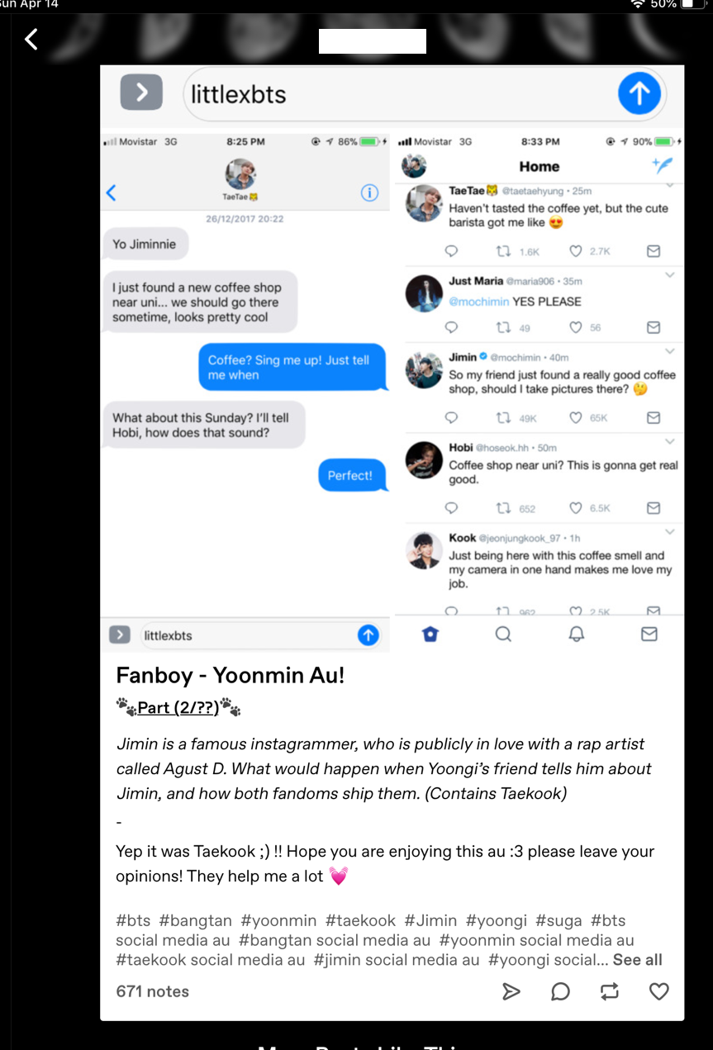

**Threadfic:**

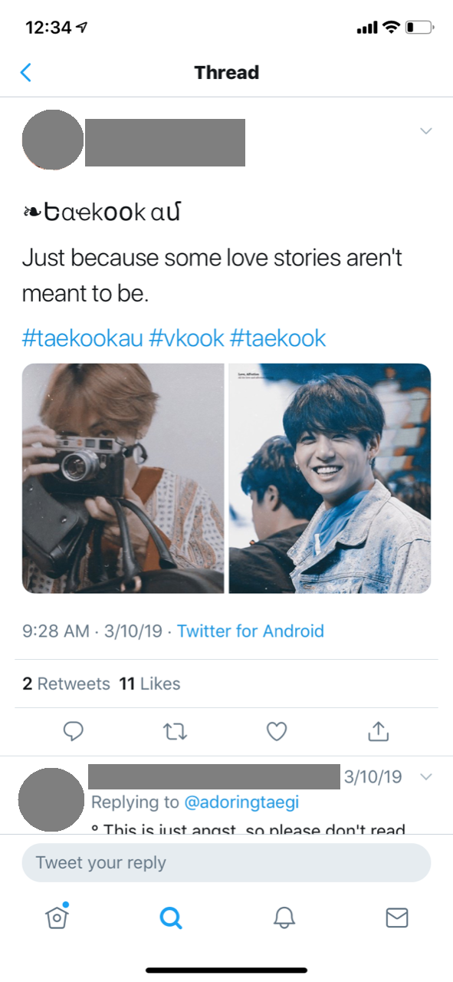 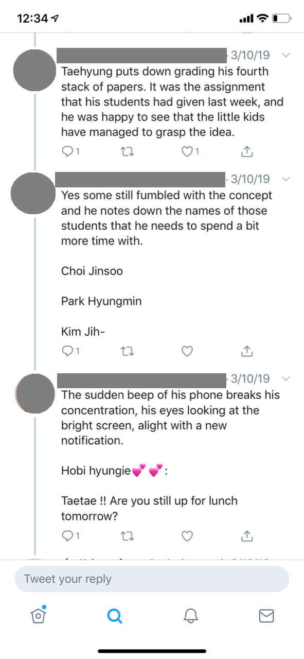

1. For more information on FellowsHub, check out <http://tolkien.raynordslab.org/cms/node/3462>. This project was introduced to me by a friend that works at the Raynor Library. The collection is still being worked on. When I talked to them about the privacy considerations for digitizing fanzines, not much consideration had been put into the fan writer’s privacy, but there is a blurb in the copyright section that allows for individual copyright claims.
2. For examples of these types of fanfiction, see the Appendix.
3. The term queer is used intentionally in this paper as an umbrella term for people in the LGBTQIA+ community.
4. I am currently working on a research project that explores kpop fanfiction writers and their experiences online and their thoughts on writing fanfiction about real people.